**5.Arduino UNO Pi platform -------** **KeyScanStart**

1. **Preparation**

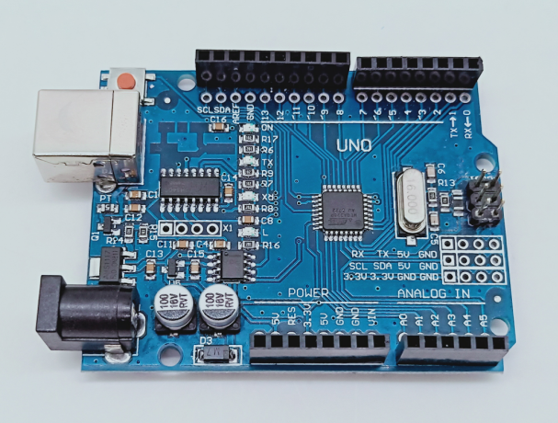

1-1 Arduino UNO board

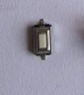

1-2 Key

**2)Purpose of Experimental**

After the code upload is completed, You need to press the KEY to start the car, the car will advance 1 s ,back 1 s,turn left 2 s,turn right 2 s, turn left in place 3 s, turn right in place 3 s, stop 0.5s.

**3)Principle of experimental**

Generally, our button switches are mechanical elastic switches. When the mechanical contacts are opened and closed, due to the elastic action of the mechanical contactor, switchs will not be able to be connected immediately when closed and it will not be disconnected at once.

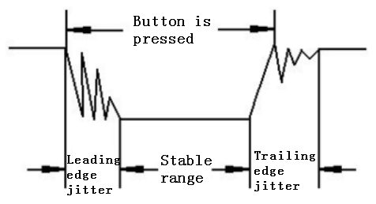

3-1 Button jitter state diagram

The jitter time is usually within 10ms. The button must be eliminated jitter to ensure that the program only responds once after the button is closed once.

In this experiment, we took the software delay eliminated jitter. After detecting that the button is closed, delay codes is executed to generate a delay of 5ms to 10ms, and the state of the button is detected again after the leading edge jitter disappears. When it is detected that the button is released, it also needs to delay 5ms~10ms.

**4)Experimental Steps**

4-1 About the schematic

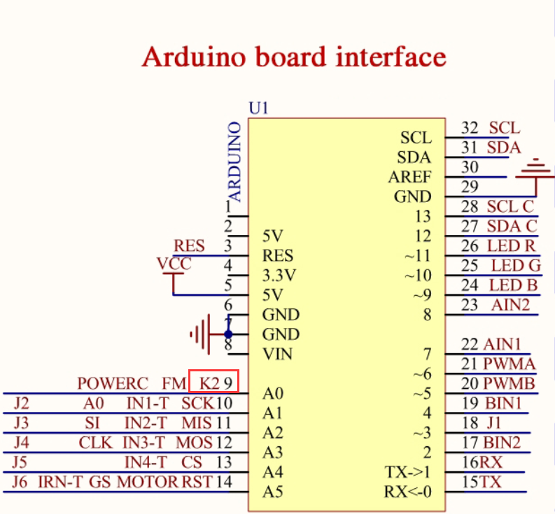

4-1 Arduino UNO interface circuit diagram

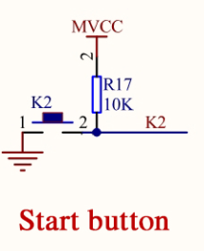

4-2 key circuit diagram

4-2 According to the circuit schematic:

Key-----A0(Arduino UNO)

4-3 About the code

1. We need to open the code of this experiment:**KeyScanStart.ino**, click“**√**” under the menu bar to compile the code, and wait for the word "**Done compiling** " in the lower right corner, as shown in the figure below.

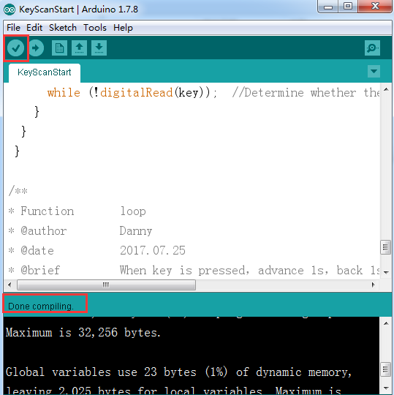

2.In the menu bar of Arduino IDE, we need to select 【Tools】---【Port】--- selecting the port that the serial number displayed by the device manager just now, as shown in the figure below.

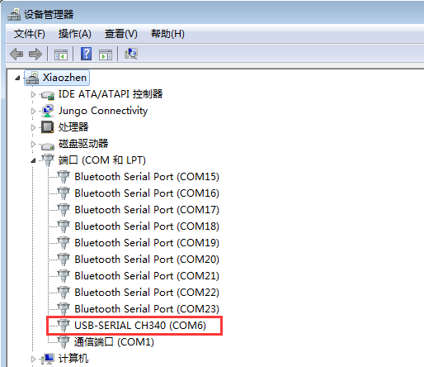

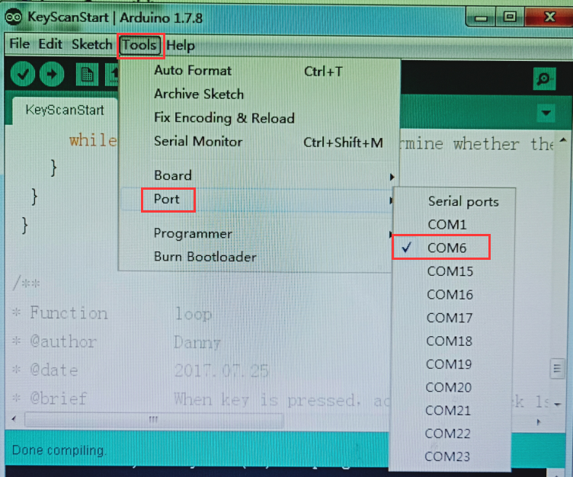

3.After the selection is completed, you need to click “**→**”under the menu bar to upload the code to the Arduino UNO board. When the word “**Done uploading**” appears in the lower left corner, the code has been successfully uploaded to the Arduino UNO board, as shown in the figure below.

